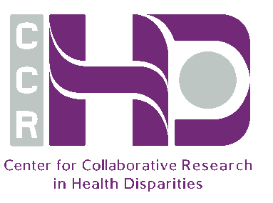
Center for Collaborative Research in Health Disparities (RCMI Program)
RCMI

29th RCMI PROFESSIONAL DEVELOPMENT Awards

Request Form 2023

First Name | Click here to enter text. | Area of research | Click here to enter text.
Last Name | Click here to enter text. | Position | Choose an item.
E-mail | Click here to enter text. | If graduate student, specify: | Choose an item.
Phone number | Click here to enter text. | If faculty, specify: | Choose an item.
School | Choose an item. | Departure date: | Click here to enter a date.
Department | Click here to enter text. | Arrival date: | Click here to enter a date.

Description of TRAINING/COLLABORATION arrangements
A brief description of the intended activity and its relevance to the applicant research development (one page). Specify expected outcome(s): i.e. Training / Publication / Grant application.

Estimated COSTS
Category | Costs ($ 0.00)
Housing | Click here to enter text.
Plane tickets | Click here to enter text.
Land transportation | Click here to enter text.
Per diem | Click here to enter text.
Registration (In person/Virtual) | Click here to enter text.
Honorarium to Collaborator (Virtual) | Click here to enter text.
Other | Click here to enter text.
Specify other | Click here to enter text.
TOTAL

CHECK LIST for this request

- Please submit your documents to rcmi.rcm@upr.edu: Check if completed:
  - Your Biographical Sketch in new format *
(Rev. 10/2024. Approved Through 09/30/2024) ☐
  - A brief description of the intended activity ☐
and its relevance to the research development
of the applicant (one page). Specify expected outcome
(i.e. Training/Publication/Grant application)
  - A letter of support from host collaborator/ ☐
laboratory
* Newest NIH form attached.
- For graduate students only please upload:
Letter of support from advisor
with copy to the School Dean ☐
(this is a requirement)

SUBMIT YOUR ELECTRONIC APPLICATION FORM TO rcmi.rcm@upr.edu by Friday, February 17, 2023. ONLY E-MAIL SUBMISSIONS WILL BE ACCEPTED.

